Project Title
Final Report: Market and Unemployment Data Analysis
Introduction
This project examines the relationship between unemployment, GDP, inflation, and interest rates to gain insights into economic trends. Using datasets sourced from Kaggle, the analysis explores workforce trends, economic health, and the factors influencing market stability.
The goal is to provide a clear and practical understanding of these economic indicators, making the findings accessible to policymakers, business analysts, and job seekers. The approach avoids complex technical models while delivering a straightforward yet insightful perspective on economic behavior.
Business Impact
Analyzing this data can help multiple stakeholders:
- Policymakers: Identify trends in unemployment and GDP to implement economic policies for job market stability.
- Businesses: Gain insights into market trends, helping with strategic planning and hiring decisions.
- Job Seekers: Understand how economic conditions influence employment opportunities and wages.
Data
- File Name: Unemployment and GDP Data
- Dataset Details: Includes economic indicators such as GDP, unemployment, inflation, interest rates, and industrial production.
- Source: Kaggle Dataset [link],[link]

Data Analysis & Computation
Data Cleaning
- Removed missing values using median imputation for numerical columns and mode imputation for categorical columns.
- Converted categorical values into a structured format for analysis.
- Interpolated missing time-series data to ensure continuity.
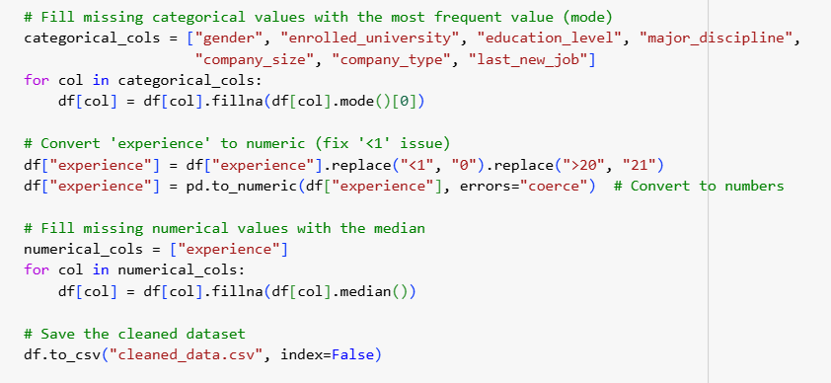
Analysis Methods
- Trend Analysis: Investigated long-term patterns in unemployment and GDP.
- Correlation Analysis: Measured relationships between GDP, inflation, unemployment, and interest rates.
- Hypothesis Testing: Evaluated the impact of unemployment on GDP using statistical tests.
- Time Series Forecasting: Used ARIMA models to predict future GDP trends.

Key Findings
Economic Trends:
- Unemployment and GDP have a negative correlation (-0.436, p < 0.001), meaning higher unemployment generally leads to lower GDP.
- T-Test results confirm that GDP is significantly lower during high unemployment periods (p < 0.001).
- GDP has shown steady growth, while unemployment fluctuates based on economic cycles.
- The ADF Test indicates GDP is non-stationary but becomes stationary after differencing.
Statistical Analysis:
- Hypothesis Testing: Unemployment significantly impacts GDP, as confirmed by both correlation and t-test results.
- 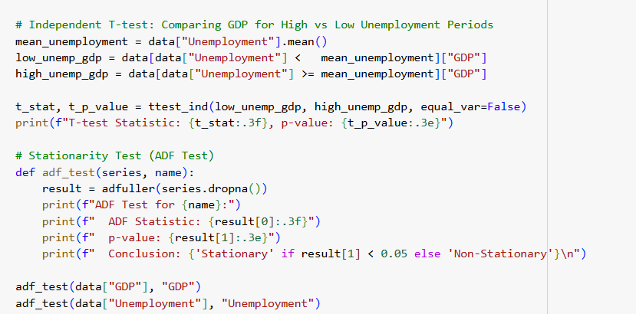
- Regression Analysis: The OLS model shows that unemployment negatively influences GDP, with an R-squared of 0.19, meaning it explains 19% of GDP variation.
- 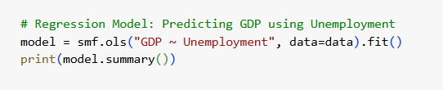
[That my code analysis]
Dashboard
An interactive dashboard was developed to visualize:
- Unemployment trends over time
- GDP fluctuations and their relationship with other economic indicators
- Forecasted GDP trends using ARIMA modeling
- [Dashboard link]

Challenges
- The dataset captures numerical trends but does not provide causal explanations for economic shifts.
- Skewed data from economic recessions and external shocks required careful handling.
- Some missing values required interpolation, which may introduce minor estimation errors.

Conclusion & Future Work
Conclusion:
- Unemployment negatively impacts GDP, supported by strong statistical evidence.
- GDP growth remains consistent over time, while unemployment exhibits cyclical patterns.
- The analysis provides valuable insights for policymakers and businesses in economic planning.
Future Work:
- Expand the analysis by incorporating external economic factors like interest rate policies and global financial events.
- Develop a more advanced forecasting model that includes economic shocks and policy changes.
- Improve dashboard functionality to provide real-time economic insights.
References & Acknowledgements
- Data Source: Kaggle
- Analysis Tools: Python (Pandas, Statsmodels, Matplotlib, Seaborn)
- Acknowledgements: Special thanks to project mentors and contributors

